Running Pipelines on Vertex AI 2.5
experimentLabschedule1 houruniversal_currency_altNo costshow_chartAdvanced
infoThis lab may incorporate AI tools to support your learning.

Overview
In this lab, you learn how to utilize Vertex AI Pipelines to execute a simple Kubeflow Pipeline SDK derived ML Pipeline.

Objectives
In this lab, you perform the following tasks:
- Set up the Project Environment.
- Inspect and Configure Pipeline Code.
- Execute the AI Pipeline.

Setup and requirements

Before you click the Start Lab button
Note: Read these instructions.
Labs are timed and you cannot pause them. The timer, which starts when you click Start Lab, shows how long Google Cloud resources will be made available to you.
This Google Skills hands-on lab lets you do the lab activities yourself in a real cloud environment, not in a simulation or demo environment. It does so by giving you new, temporary credentials that you use to sign in and access Google Cloud for the duration of the lab.

What you need
To complete this lab, you need:
- Access to a standard internet browser (Chrome browser recommended).
- Time to complete the lab.
Note: If you already have your own personal Google Cloud account or project, do not use it for this lab.
Note: If you are using a Pixelbook, open an Incognito window to run this lab.

How to start your lab and sign in to the Console
- Click the Start Lab button. If you need to pay for the lab, a pop-up opens for you to select your payment method. On the left is a panel populated with the temporary credentials that you must use for this lab.
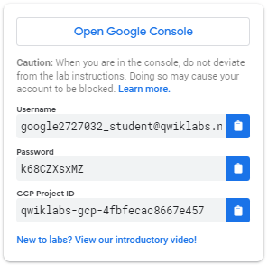
- Copy the username, and then click Open Google Console. The lab spins up resources, and then opens another tab that shows the Choose an account page.
- Note: Open the tabs in separate windows, side-by-side.
- On the Choose an account page, click Use Another Account. The Sign in page opens.
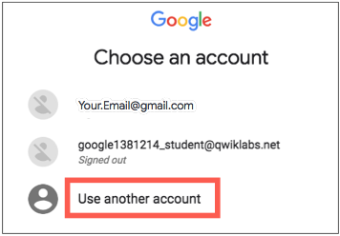
- Paste the username that you copied from the Connection Details panel. Then copy and paste the password.
Note: You must use the credentials from the Connection Details panel. Do not use your Google Skills credentials. If you have your own Google Cloud account, do not use it for this lab (avoids incurring charges).
- Click through the subsequent pages:
- Accept the terms and conditions.
- Do not add recovery options or two-factor authentication (because this is a temporary account).
- Do not sign up for free trials.
After a few moments, the Cloud console opens in this tab.
Note: You can view the menu with a list of Google Cloud Products and Services by clicking the Navigation menu at the top-left. 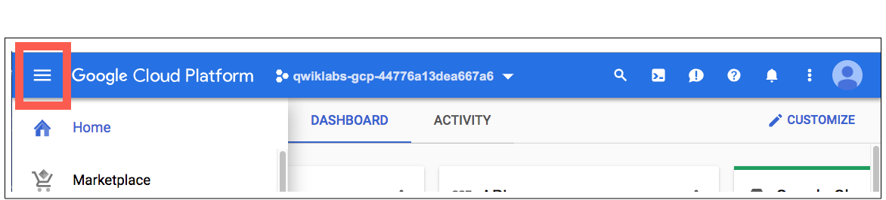

Check project permissions
Before you begin your work on Google Cloud, you need to ensure that your project has the correct permissions within Identity and Access Management (IAM).
- In the Google Cloud console, on the Navigation menu (), select IAM & Admin > IAM.
- Confirm that the default compute Service Account {project-number}-compute@developer.gserviceaccount.com is present and has the editor role assigned. The account prefix is the project number, which you can find on Navigation menu > Cloud Overview > Dashboard.
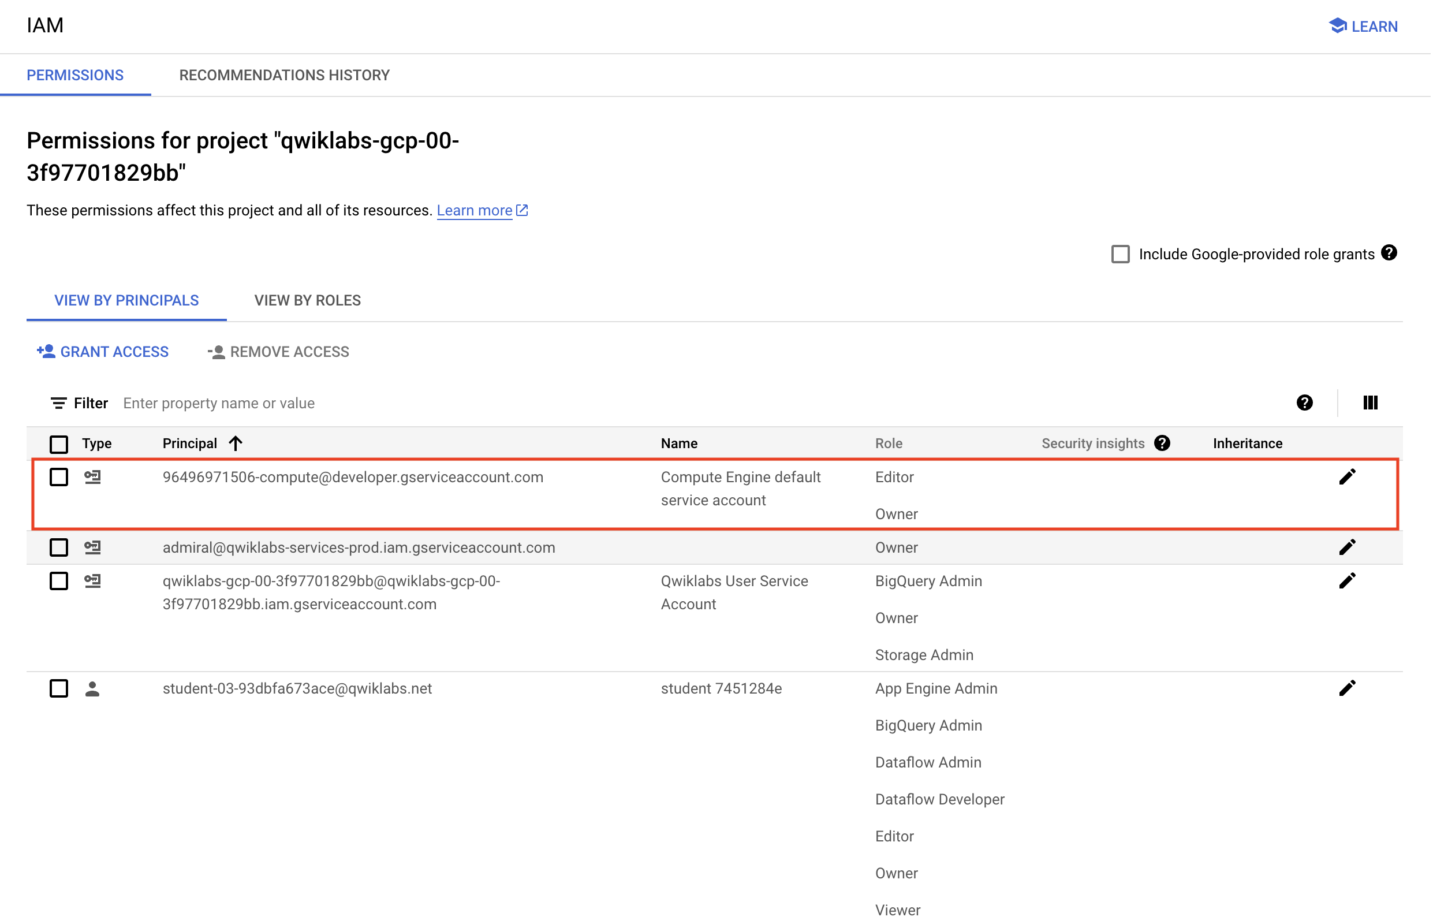
Note: If the account is not present in IAM or does not have the editor role, follow the steps below to assign the required role.
- In the Google Cloud console, on the Navigation menu, click Cloud Overview > Dashboard.
- Copy the project number (e.g. 729328892908).
- On the Navigation menu, select IAM & Admin > IAM.
- At the top of the roles table, below View by Principals, click Grant Access.
- For New principals, type:
{project-number}-compute@developer.gserviceaccount.com
Copied!
- Replace {project-number} with your project number.
- For Role, select Project (or Basic) > Editor.
- Click Save.

Task 1. Set up the project environment
Vertex AI Pipelines run in a serverless framework whereby pre-compiled pipelines are deployed on-demand or on a schedule. In order to facilitate smooth execution some environment configuration is required.
For the seamless execution of Pipeline code in a Google Skills environment the Compute Service Account needs elevated privileges on Cloud Storage.
- In the Google Cloud console, on the Navigation menu (), click IAM & Admin > IAM.
- Click the pencil icon for default compute Service Account {project-number}-compute@developer.gserviceaccount.com to assign the Storage Admin role.
- On the slide-out window, click Add another role. Type Storage Admin in the search box. Select Storage Admin with Grants full control of buckets and objects from the results list.
- Click Save to assign the role to the Compute Service Account.
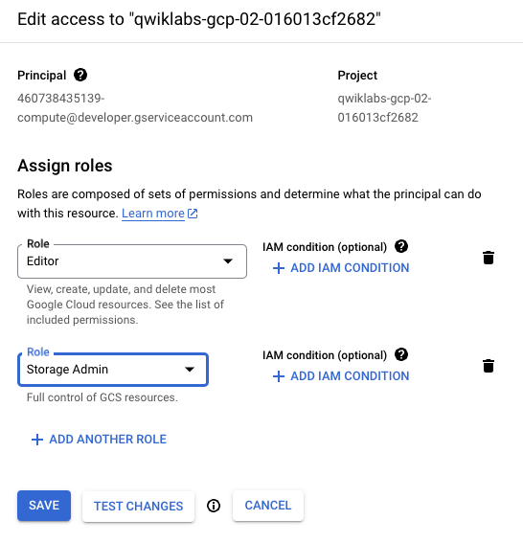
Artifacts will be accessed on ingest and export as the Pipeline executes.
- Run this code block in the Cloud Shell to create a bucket in your project and two folders each with an empty file:
gcloud storage buckets create gs://Project ID
touch emptyfile1
touch emptyfile2
gcloud storage cp emptyfile1 gs://Project ID/pipeline-output/emptyfile1
gcloud storage cp emptyfile2 gs://Project ID/pipeline-input/emptyfile2
Copied!
The Pipeline has already been created for you and simply requires a few minor adjustments to allow it to run in your Google Skills project.
- Download the AI Pipeline from the lab assets folder:
wget https://storage.googleapis.com/cloud-training/dataengineering/lab_assets/ai_pipelines/basic_pipeline.json
Copied!
Click Check my progress to verify the objective.
Configure the environment

Task 2. Configure and inspect the Pipeline code
The Pipeline code is a compilation of two AI operations written in Python. The example is very simple but demonstrates how easy it is orchestrate ML procedures written in a variety of languages (TensorFlow, Python, Java, etc.) into an easy to deploy AI Pipeline. The lab example performs two operations, concatenation and reverse, on two string values.
- Inspect basic_pipeline.json to confirm that the output folder is set to your project:
head -20 basic_pipeline.json
Copied!
The key sections of code in basic_pipeline.json are the deploymentSpec and command blocks. Below is the first command block, the job that concatenates the input strings. This is Kubeflow Pipeline SDK (kfp) code that is designated to be executed by the Python 3.13 engine. You will not change any code, the section is shown here for your reference:
"program_path=$(mktemp -d)\n\nprintf \"%s\" \"$0\" > \"$program_path/ephemeral_component.py\"\n_KFP_RUNTIME=true python3 -m kfp.dsl.executor_main --component_module_path \"$program_path/ephemeral_component.py\" \"$@\"\n",
"\nimport kfp\nfrom kfp import dsl\nfrom kfp.dsl import *\nfrom typing import *\n\ndef concat(a: str, b: str) -> str:\n return a + b\n\n"
],
"image": "python:3.13"
- You can explore the entire file by issuing the command below:
more basic_pipeline.json
Copied!
Note: Press the spacebar to advance through the file until its end. If you wish to close the file early, type q to close the more command.
- Next, move the updated basic_pipeline.json file to the Cloud Storage bucket created earlier so that it can be accessed to run an AI Pipeline job:
gcloud storage cp basic_pipeline.json gs://Project ID/pipeline-input/basic_pipeline.json
Copied!
Click Check my progress to verify the objective.
Deploy Pipeline

Task 3. Execute the AI Pipeline
- From the Console, open the Navigation menu (), click Vertex AI > Dashboard.
- Click Enable all recommended APIs.
- Once the API is enabled, click Pipelines in the left menu.
- Click Create run on the top menu.
- From Run detail, select Import from Cloud Storage and for Cloud Storage URL browse to the pipeline-input folder you created inside your project's cloud storage bucket. Select the basic_pipeline.json file.
- Click Select.
- For Region select REGION
- Leave the remaining default values, click Continue.
- Set the output directory for the pipeline. Choose Browse, and select the pipeline-output folder within the bucket provided to your project.
You may leave the default values for Runtime configuration. Notice that the Cloud Storage Output Directory is set to the bucket folder created in an earlier step. The Pipeline Parameters are pre-filled from the values in the basic_pipeline.json file but you have the option of changing those at runtime via this wizard.
- Click Submit to start the Pipeline execution.
Note:If you see the message Internal error encountered, please wait 1-2 minutes. Then create a new run by following Task 3 steps 3-9 again.
- You will be returned to the Pipeline dashboard and your run will progress from Pending to Running to Succeeded.
Note: The entire run will take between 3 and 6 minutes to complete.
- Once the status reaches Succeeded, click on the run name to see the execution graph and details.
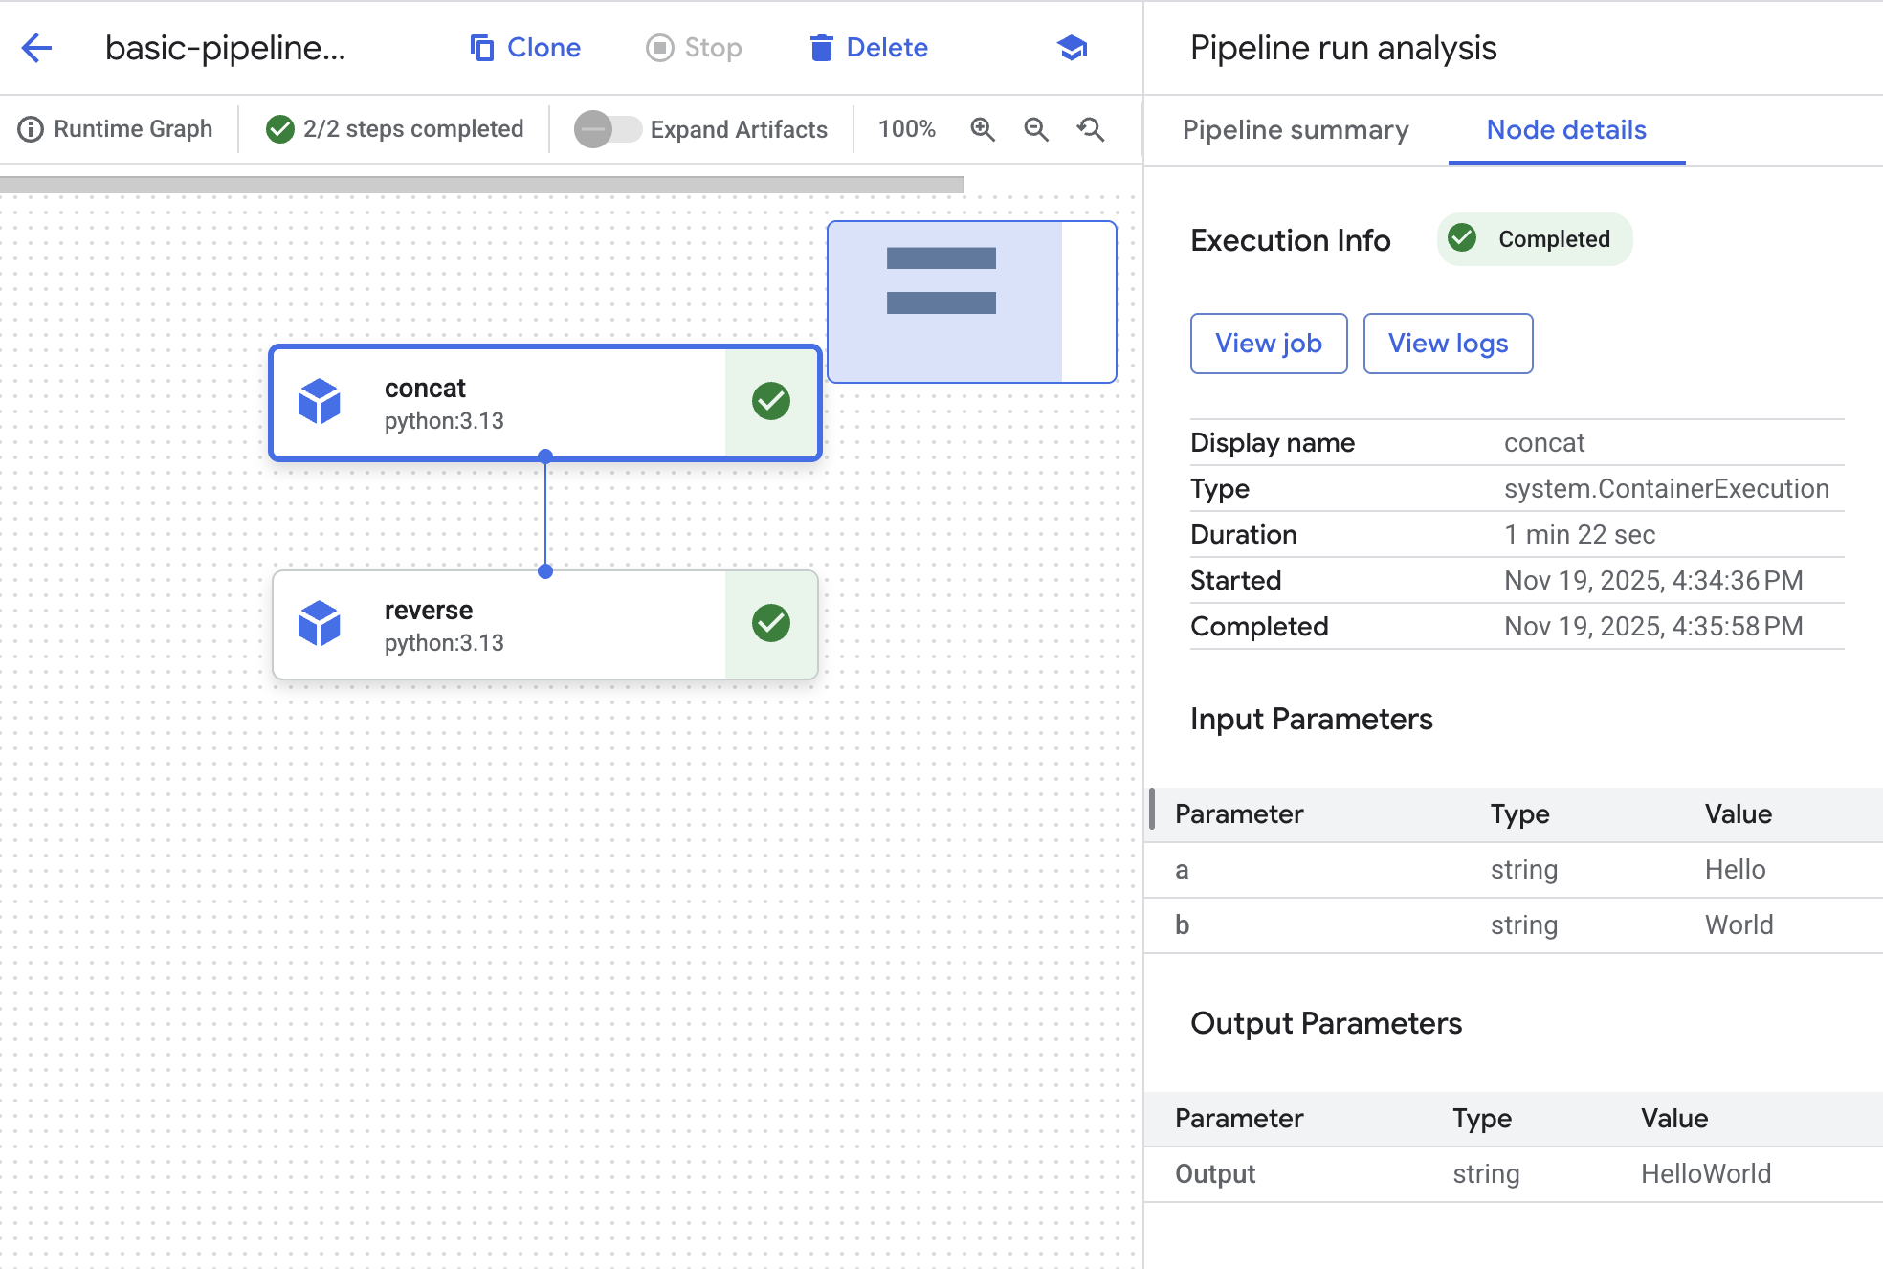
- A graph element exists for each step. Click on the concat object to see the details for the job.
- Click on the View Job button. A new tab will open with the Vertex AI Custom Job that was submitted to the backend to satisfy the pipeline request.
Feel free to explore more details on the Pipeline execution.

Congratulations!
You have successfully used Vertex AI Pipelines to execute a simple Kubeflow Pipeline SDK derived ML Pipeline.
Manual Last Updated March 30, 2026
Lab Last Tested March 30, 2026
Copyright 2026 Google LLC All rights reserved. Google and the Google logo are trademarks of Google LLC. All other company and product names may be trademarks of the respective companies with which they are associated.

